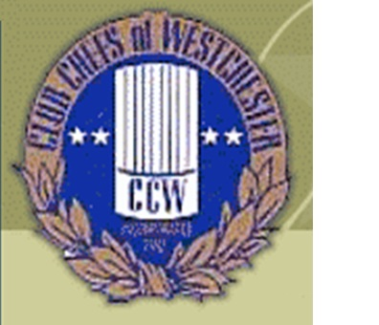

Club Chefs of Westchester Chris Gasse Foundation Golf Outing
October 18, 2016 at Waccabuc Country Club
Please email Lenny Phillips lphillips@shenorockshoreclub.org
to reserve a four some, and mail in a check to address below.

Breakfast 9am, 11am Shotgun followed by
Dinner, Raffle and Awards.
$200.00 per Golfer $800.00 per Foursome $75.00 BBQ only

Name _____________________________________________
Name _____________________________________________
Name _____________________________________________
Name _____________________________________________
Number Attending for Golf @$200.00Ea.________
Number Attending for BBQ
@$75.00 Ea._______________

Clubs Name ___________________________________

Make Checks Payable to Club Chefs of Westchester
P.O. Box 732
Bronxville, NY 10708

